Interactive screen scheme infrastructure

System DB infrastructure is implemented using MongoDB

DB structure details:

* + Name: advertisement
  + Collection:
    - msgs
    - screens
  + Port: 27017

## Collection msgs

msgs collection is holding 5 objects that representing a single advertisement message.

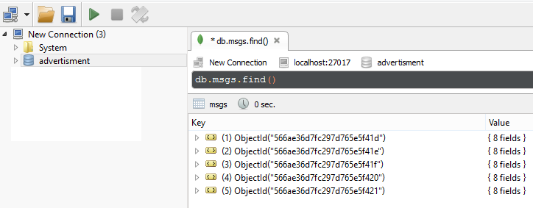

Each object has the following structure (will be explained later):

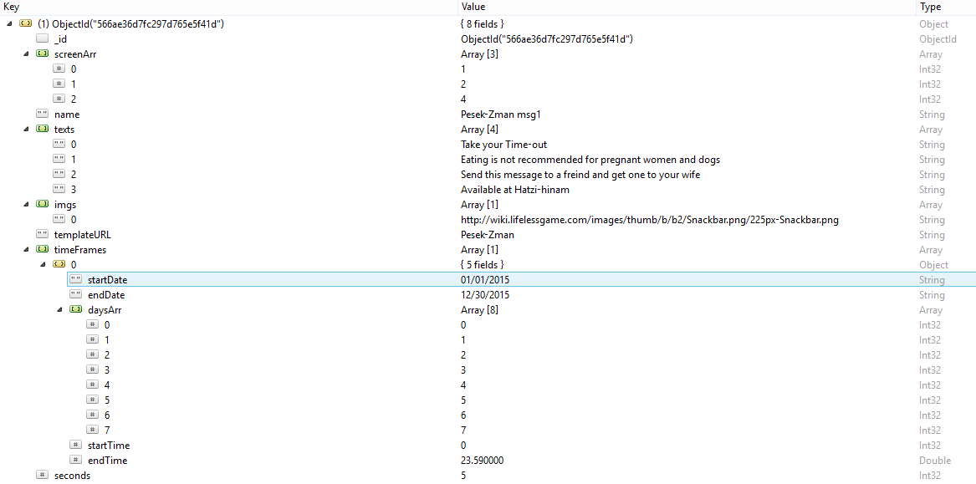

**DB main Objects**

All objects can be found under “Advertisment.JSON” (Attached at my exercise folder)

Each object has 8 fields:

|  |  |  |
| --- | --- | --- |
| Type | Name | Purpose |
| ObjectId | _id | represent the object ID |
| String | Name | represent the name of the message that contained in the object |
| Array(Int32) | screenArr | represent an array of Int32 with allowed interactive screens to display the message |
| Array(String) | texts | represent an array of text fields of the message |
| Array(String) | imgs | represent an array of images links of the message |
| String | temlateURL | represent a string of the name of the message template |
| Array(Object) | timeFrames | represent an array of timeFrames object for the message |
| Int32 | seconds | represent the time in seconds to display the message |

For example you can look at this Object:

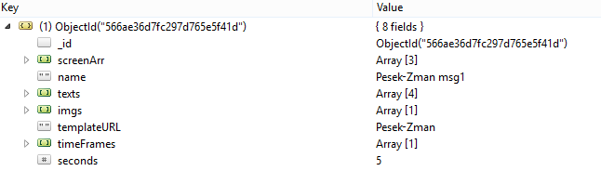

**timeFrame Object structure**

Each time frame has 5 fields:

|  |  |  |
| --- | --- | --- |
| Type | Name | Purpose |
| String | startDate | Represent the date that the message should start to being displayed at the following format: “MM/DD/YYYY” |
| String | endDate | Represent the date that the message should stop to being displayed at the following format: “MM/DD/YYYY” |
| Array(Int32) | daysArr | Array of dates as Integers represent the day of the week (from 0 to 6) for the specified date. Note: Sunday is 0, Monday is 1, and so on. |
| Double \Int32 | startTime | Represent the hour and minutes at specific day to start display the message |
| Double \Int32 | endTime | Represent the hour and minutes at specific day to stop display the message |

For example you can look at this timeframe array, containing 1 timeFrane object:

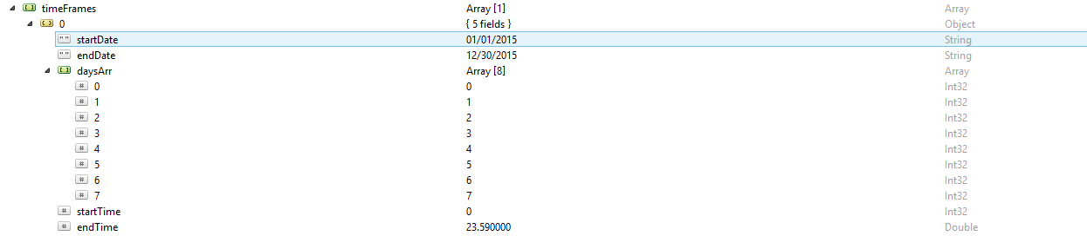

## Collection screens

screens collection is holding 5 objects that representing a single advertisement screen.

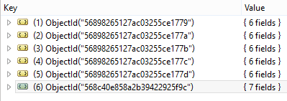

Each object has the following structure (will be explained later):

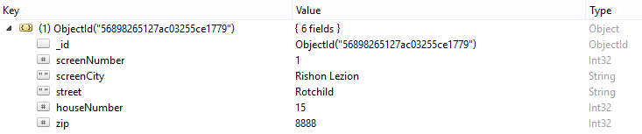

**DB main Objects**

All objects can be found under “Screens.JSON” (Attached at my exercise folder)

Each object has 8 fields:

|  |  |  |
| --- | --- | --- |
| Type | Name | Purpose |
| ObjectId | _id | represent the object ID |
| Int32 | screenNumber | represent the url “screen id” |
| String | screenCity | Represent the city of the screen |
| String | street | Represent the street of the screen |
| Int32 | houseNumber | Represent the house number of the screen location |
| Int32 | zip | Represent ZIP code of the screen |